**Sunrise Decorative Floating Wall Shelf in Antique Brass**

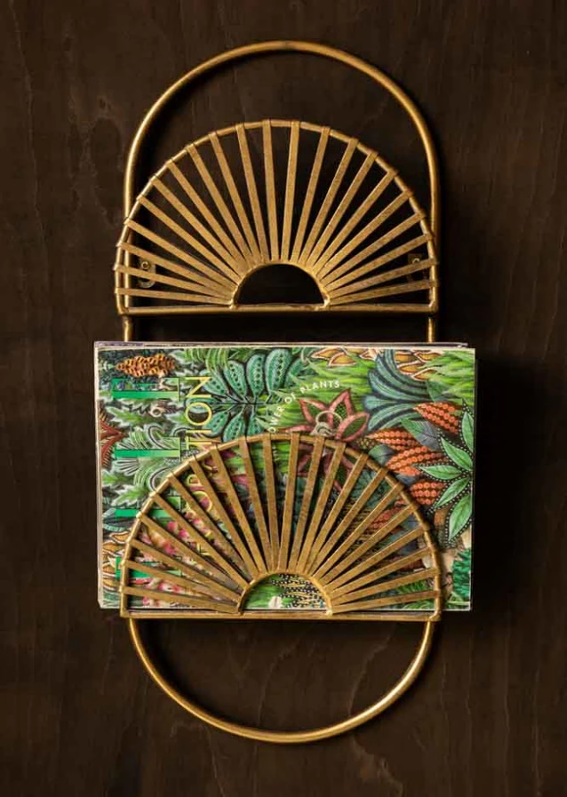 The Sunrise Decorative Floating Wall Shelf in antique brass is a statement piece that blends artistry with functionality. Featuring a semi-circular design reminiscent of a rising sun, this shelf boasts an elegant antique brass finish that adds warmth and sophistication to any space. Perfect for displaying small decor items, plants, or candles, it serves as both a practical storage solution and a stunning wall accent. Its unique design makes it a versatile addition to modern, vintage, or eclectic interiors, elevating the aesthetic appeal of any room.